Latest News
Sunday 15 Mar 2017
From: Christina Fonfe
Received by: Email.
A Few Words on Our Different Approach to Beginner Swimming

As we begin a Student Swimming Teacher’s Course in March, it is worth reflecting on how different our initial steps in teaching adult and teenaged total non-swimmers is to mainstream ‘conventional’ methods. After more than a decade of ‘doing it differently’ we see a gentle paradigm change of direction away from speed and distance to survivability and endurance as the measures of merit in swimming. Of, course we applaud and reward competition, but swimming should be like walking, a natural, effortless, automated experience in a magic aquatic environment.

Learning to walk before one can run is to totally master one skill set before beginning another. And so it is with swimming, except that when you ‘fall down’ it is into a hostile, airless, slippery, suffocating water-filled environment. For this reason alone, we consider there is one skill, above all others, that has to be mastered as early as possible when contemplating immersion in water and that is how to keep your airway open without physically exhausting yourself in the process. It’s called floating on your back and it is amazing just how few ‘swimmers’ can do it for more than a few seconds.

The way we teach the initial lessons is far removed from the way conventional mass swimming classes are conducted. A detailed explanation of our training is needed. Our core principal is that survivability demands the ability to guarantee an open airway in an aquatic environment; this is the paramount skill to be learned. It is embodied in our diktat for survival: Float-and-Breathe First, Then Swim.

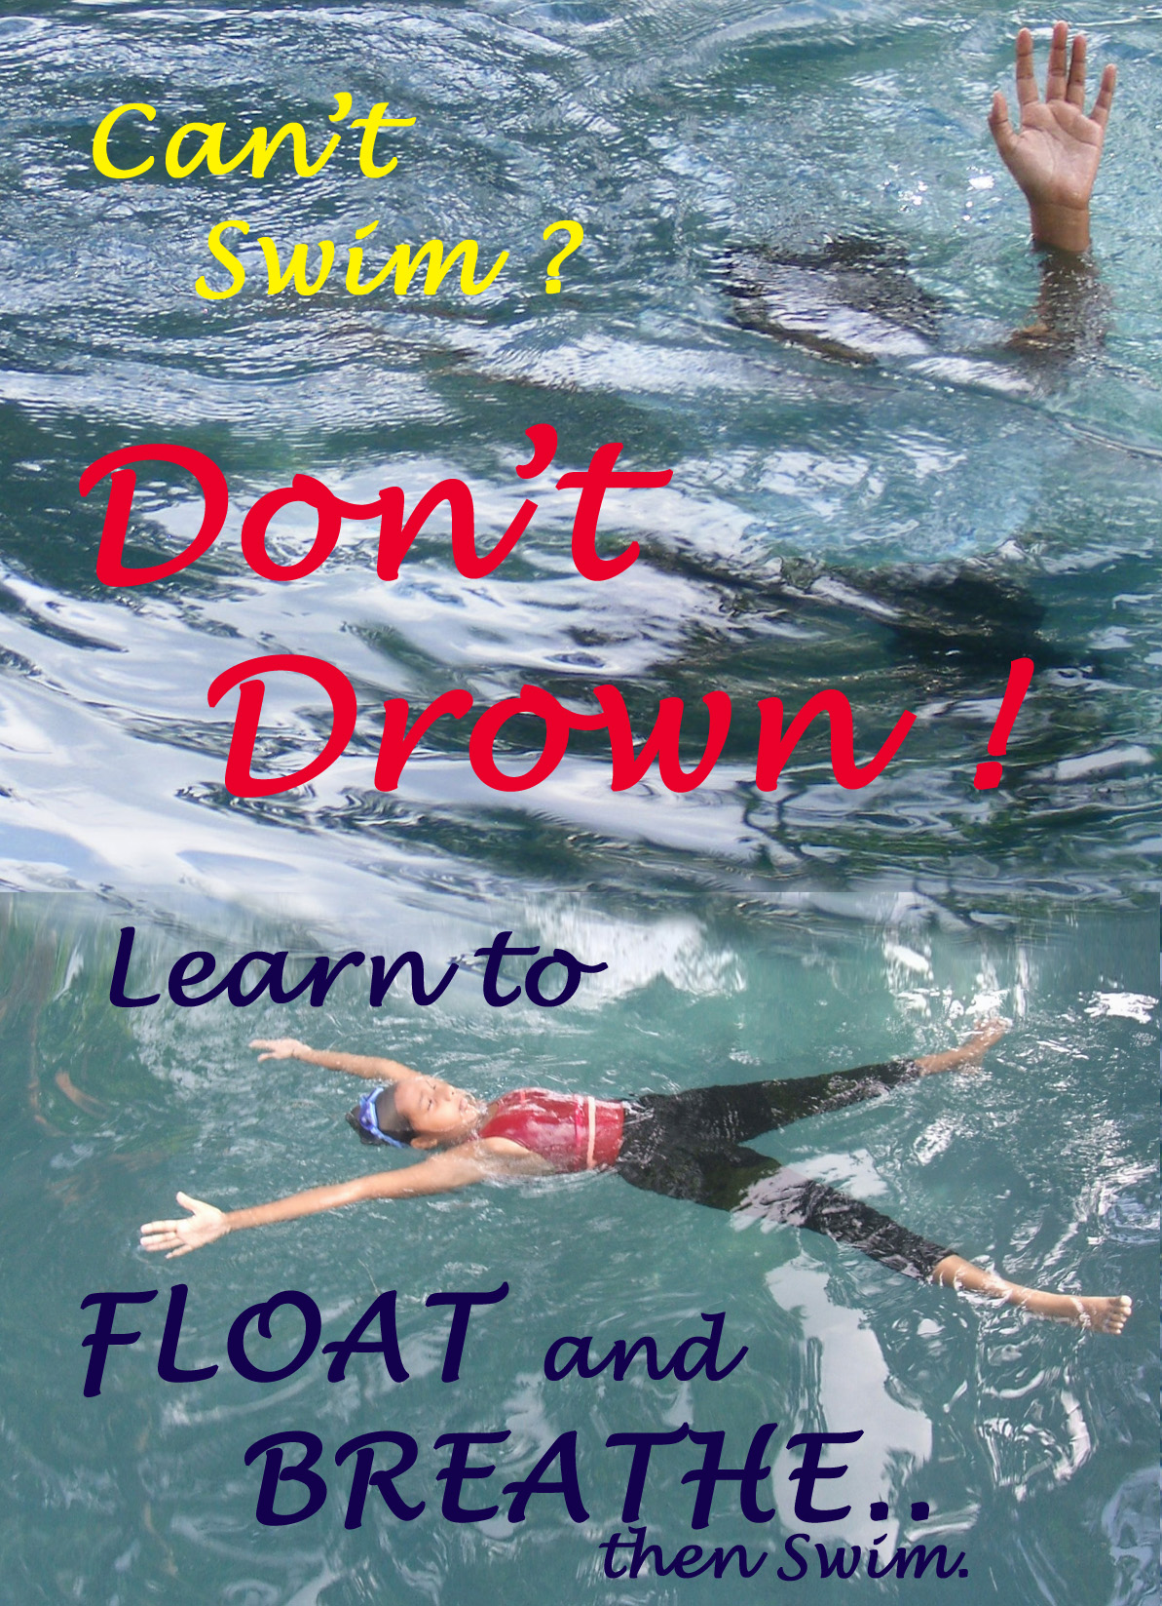
It has to be remembered that virtually all of the adults and teenagers we teach in Sri Lanka have never been in a swimming pool; they have not even had the chance to lie down full length in a bath as they only shower or wash with buckets and basins. At best, a daring few might have had a knee-deep paddle at the seaside. The cultural rural and coastal norm is ‘Keep away from water or you will drown’. So, compared to people in the West, our students have missed out a lifetime of childhood water-play developmental experiences. On the other hand, our students have no ingrained, previous negative experiences to make them fearful of water and this innocence is a precious gift to the swimming teacher.

By careful introduction and absolute one-on-one trust, with the teacher in the water, our adult and teenage students can, within the first few lessons, totally master the art of floating on their backs in a star shape position to guarantee their airways are open to the atmosphere. The time this takes varies from student to student, depending on many factors, but we begin it on Day One of the course.

They are first introduced to feel the fluidity and resistance of moving water and the difference between smooth flow, turbulent flow and aeration by walking, striding and hopping, backwards and forwards, around the pool, with a running commentary from the teacher. As they move, they are told to feel the water pressure on their legs and open hands and are led to discover that moving too quickly introduces turbulence, increases resistance and alters balance. Meanwhile, the teacher is already noting who is balanced, confident or, in some cases, over-confident. The students learn they can breathe through their noses even while their mouths are open under water. They can still breathe when their noses are just millimetres above the water surface. We have a mirror on the pool floor so they can observe their own breath control as they progress to putting their faces fully into the water and breathe-out slowly through nose and mouth, under water, with their feet still firmly on the pool floor.

Next comes the supported and unsupported Mushroom Floating: with face in the water, arms hanging down and pressing down towards touching their toes, they discover their feet come off the pool floor and they are floating. Varying the size of breath-holds demonstrates the direct controlling effect on buoyancy and they learn another important skill: how to stand up. This is followed by the Egg Float, where they draw their legs up and clutch them into a tight ball, before finding their feet and standing up to breathe, In the Egg Float, they learn that only small movements of head and hands are needed to alter body position and they learn to spin
and rock the Egg with minimal hand action.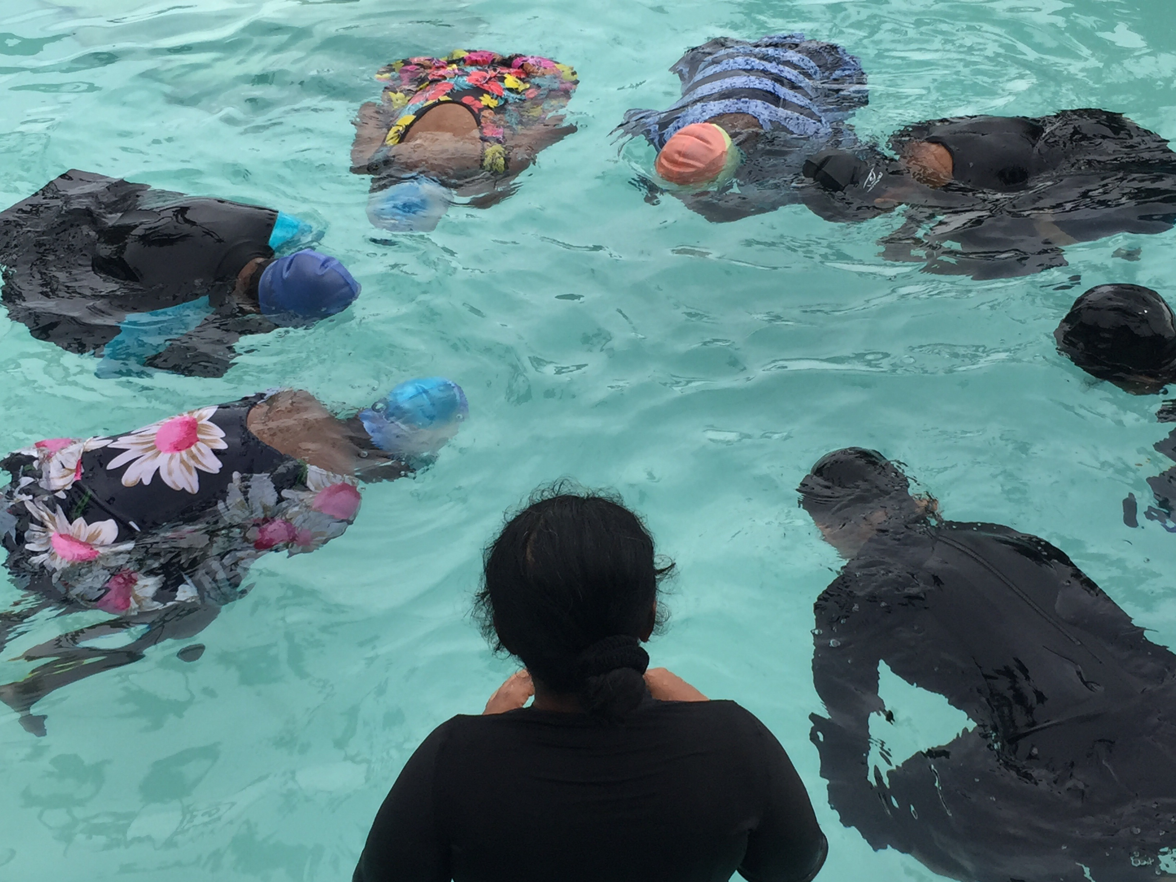
A sustained duration Egg Float introduces balance and fine motor control.

After careful explanation, the final piece de resistance of Egg-Floating is for the student Egg to be gently pressed to the pool floor and allowed to rise to the surface under their own buoyancy and stand up unassisted. If one closes one’s eyes, this is a magic experience: rising up gently, defying gravity for several seconds; the nearest anyone can truly get to the sensation of yogic flying!

The key experiences learned so far are Breath Control and Buoyancy - If you do nothing, you will definitely float. And that to Maintain Balance and Control Movement, only small inputs of energy are needed; anything more is simply a balance destabilizing, wasted effort. At this point, breathing-in only takes place when stood up fully, head well out the water.

Egg Floats are then transitioned into balancing while changing body shapes, still face-down, into ‘I’, ‘Y’ and ‘X’ Floats. When these are confidently achieved, the student is ready for the next skill: ‘Gliding on the Surface’, achieved by a gentle push on the soles of the feet of a student in an ‘I’-Float, followed by standing up to breathe. The ‘I’-Float glide distance demonstrates, again, how little energy is needed to get moving, and how streamlining can maintain momentum over a considerable distance. We generally achieve Gliding on the Surface in the first lesson. At no point yet has the student attempted any kind of stroke.

Having mastered face-down floating, it is but a simple thing to explain to the student that if they can balance face-down so easily without breathing, then they should be able, with a little help from the teacher, to balance face-up and breathe unrestrictedly. The student is reminded that to float successfully in fresh water, most of the head must be submerged and that to be flat on the surface of the water, the body, head and spine, must be aligned and relaxed, flexible enough to adjust to any waves. If they do this, we tell them that, truthfully, the water will hold them up; wriggle and panic and disturb the water, and it will fold over you.

At all times, the teacher will stand behind and support the student to avoid accidental submerging of the face until such time that the student can consistently achieve a balanced back float every time. The student is also told how and where the teacher’s hand support will be: across the upper arms, under the shoulder blades, the neck, waist and under the knees. Finally, when proper balance is achieved, a gentle push to the ankles and soles of the feet will bring on an effortless glide. At the end of a back-float-and glide, the student will be shown how to find their feet again in order to stand up again, just as they did from a static back-float.

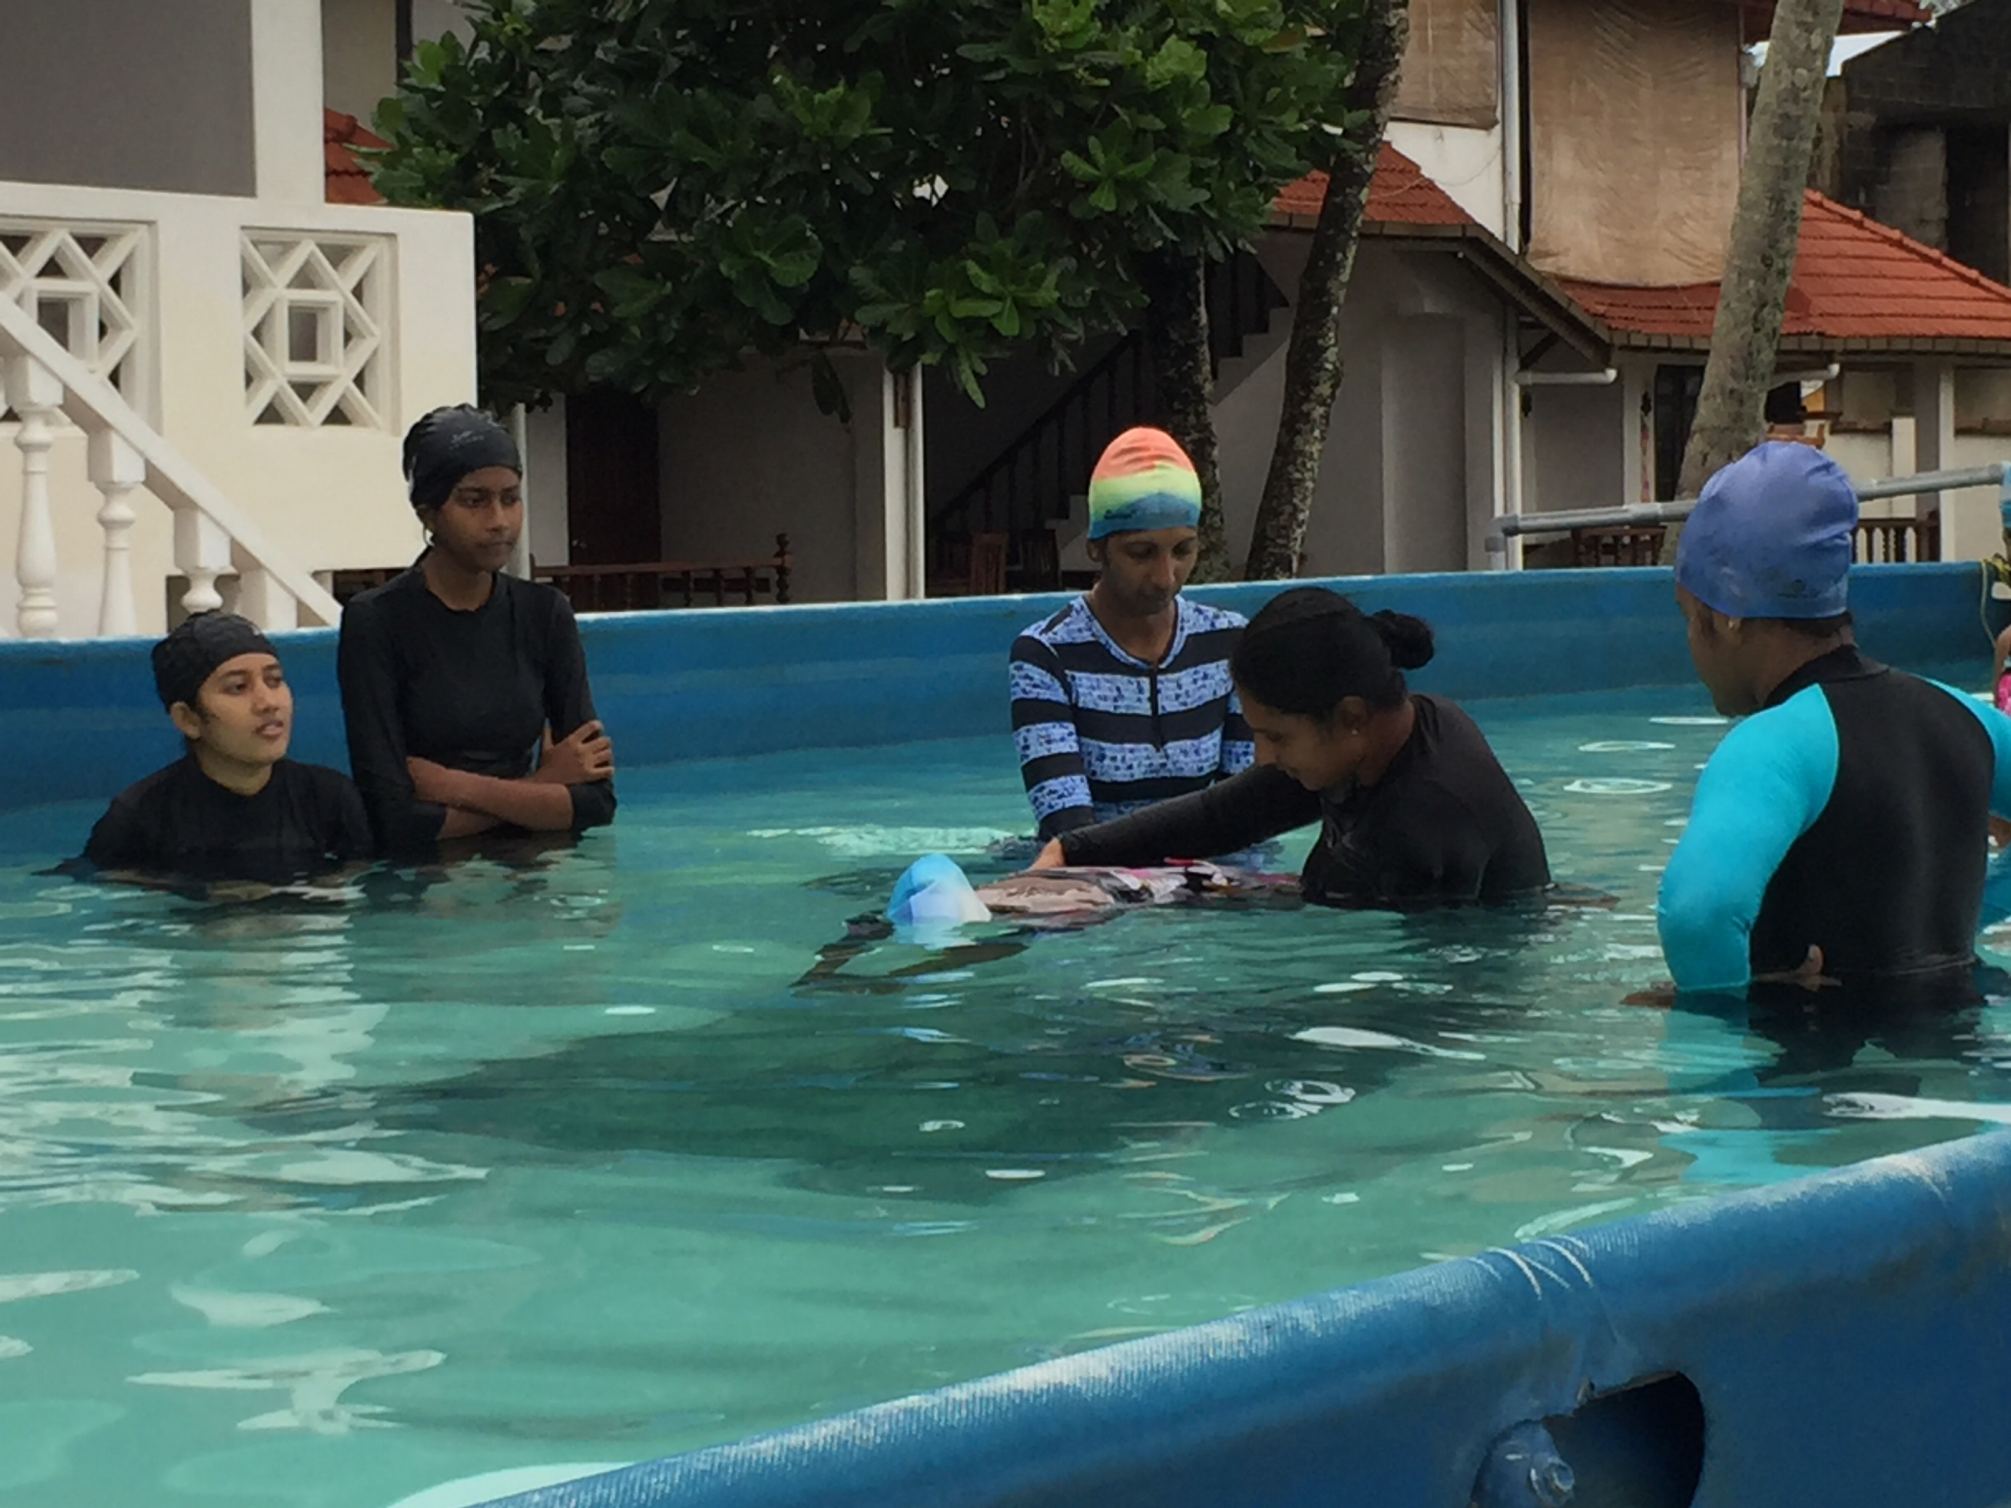
A gentle push is all that is needed to make a streamlined body glide a long way.
The mirror on the pool floor enables students to see they are properly streamlined.
Student Teachers are learning where to place their hands appropriately to achieve this.

With Gliding comes the practical application of Newton’s Laws of Motion: (1) Push the water and you will move in the opposite direction and (2) Once you are moving, you will keep moving a long way without doing anything else, as long as you stay streamlined and do not push any water in any other, unwanted direction. The result is that most of our students achieve a face-in push-and-glide right across our six metre -wide pool in the first or second lesson. Some will even manage to sustain a back-float-and-glide by gentle leg kicking to propel themselves along, meaning they will have achieved their first solo “swim” of the day.

The key is, of course, is to avoid allowing any student to accidentally snort up a painful nose-full of water or choke on a misplaced underwater gasp, either of which will erode confidence hugely and reinforce any adverse fear of water they may already have. Learning how to deliver this hands-on, with absolute student trust in teacher close support, with never-a-fraction-of-a-second’s slip-up, is the foremost important training skill that marks transition of a swimmer into a swimming teacher.

A significant number of students do have difficulty mastering effective alternating leg kicking while maintaining a good, flat body position in the water. To overcome this, the teacher will support and tow the student by walking backwards. Some water is dragged along by teacher’s body and this ‘pull’ assists the student in developing a good leg kick. The proximity of the teacher ensures the student is not tempted to lift their head out of the water or ‘banana’ the spine. Eventually, the student’s kick will be strong enough for the teacher to lighten and then release hand support until the student can swim lengths on their backs for themselves. Concurrently, and by way of variety, head-first back-sculling is introduced and, once students are reasonably competent, feet-first sculling really reinforces breathing, balance and straight spines.

Our certification of achievement reflects the importance of survivability – it is not how far or fast can you swim, but how long can you survive for and how far can you travel to save yourself ; the two are inseparably linked. The benefit of this intense concentration on floating is that when it comes to teaching stroke, any stroke, our students are already horizontally balanced, breathing easily and streamlined, which makes the transition to core body rotation and splash-less stroke action much, much easier. One way we do this is for the student to do three stokes of backstroke, rolling over face-in to three stoke of front crawl whilst breathing out underwater, and then roll back to resume backstroke and breathe in. Taken together, this introduces core body rotation and stroke synchronized with bilateral breathing in an easily sustainable rhythm. Breathlessness and the need to breathe overrides all other actions in the water. Breathless is when it is time to roll over, relax, balance in a face-up float and re-oxygenate the body and relax to think about what to do next.

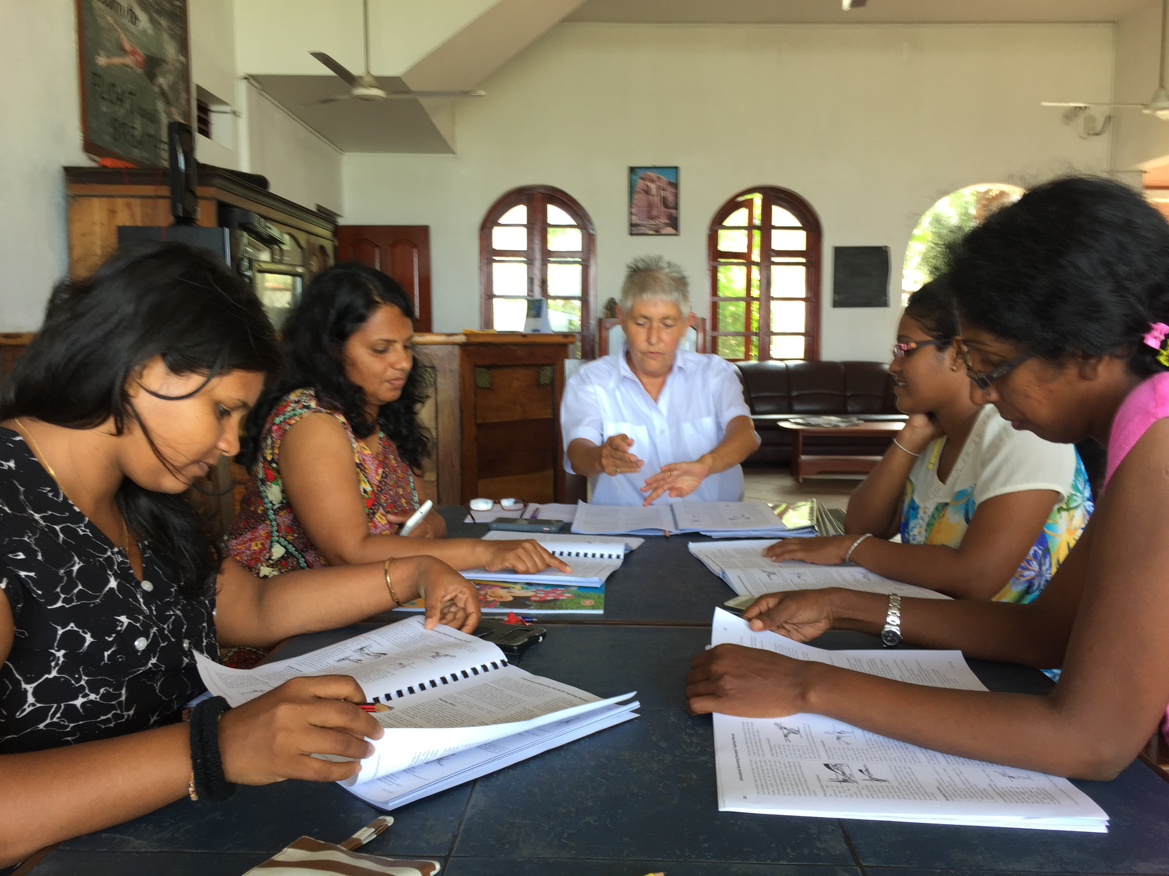
The Swim Manual opens up a new world of Health & Safety, Risk Assessment,
Duty of Care, Rescue and CPR, as well the theories of learning and teaching.

For the Student Teachers, the ability to master and manage the student’s transition from non-swimmer to swimmer in a consistent sequence, building up of each critical step at the non-swimmers rate of learning progress, is the key to rapid early progress. This requires the would-be teachers to learn not just the demonstrations and body holds but calls foir a consistent vocabulary of words to match the actions. We call this Swimlish, an internationally recognizable vocabulary of all the words, phrases and sentences needed to teach swimming in English. Add to this the absolute need for safety awareness in and near water and the skills and actions required in an emergency when things go wrong. Suddenly there is a lot to learn to become a swimming teacher in Sri Lanka. The STA Student Teacher course is the perfect vehicle for introducing these wider responsibilities.

We also follow German legal notion that there is no such thing as an accident: the cause can always be traced back to an error or an omission; this is the exact opposite of kharma or fate, a concept deeply embedded in local Asian cultural beliefs in astrology and the cosmic, pre-ordained nature of events. For many, risk assessment, anticipation, training for untoward possibilities and intervention are new concepts; pool rescue and CPR are the best illustrations that kharma can be challenged and defeated. Death is not always a necessarily foregone conclusion.
The New Kharma is that there is now somebody there, a swimming teacher and a group of swimmers who know what to do. With them and CPR, you can be rescued and saved; it is not your day to die. Kharma!

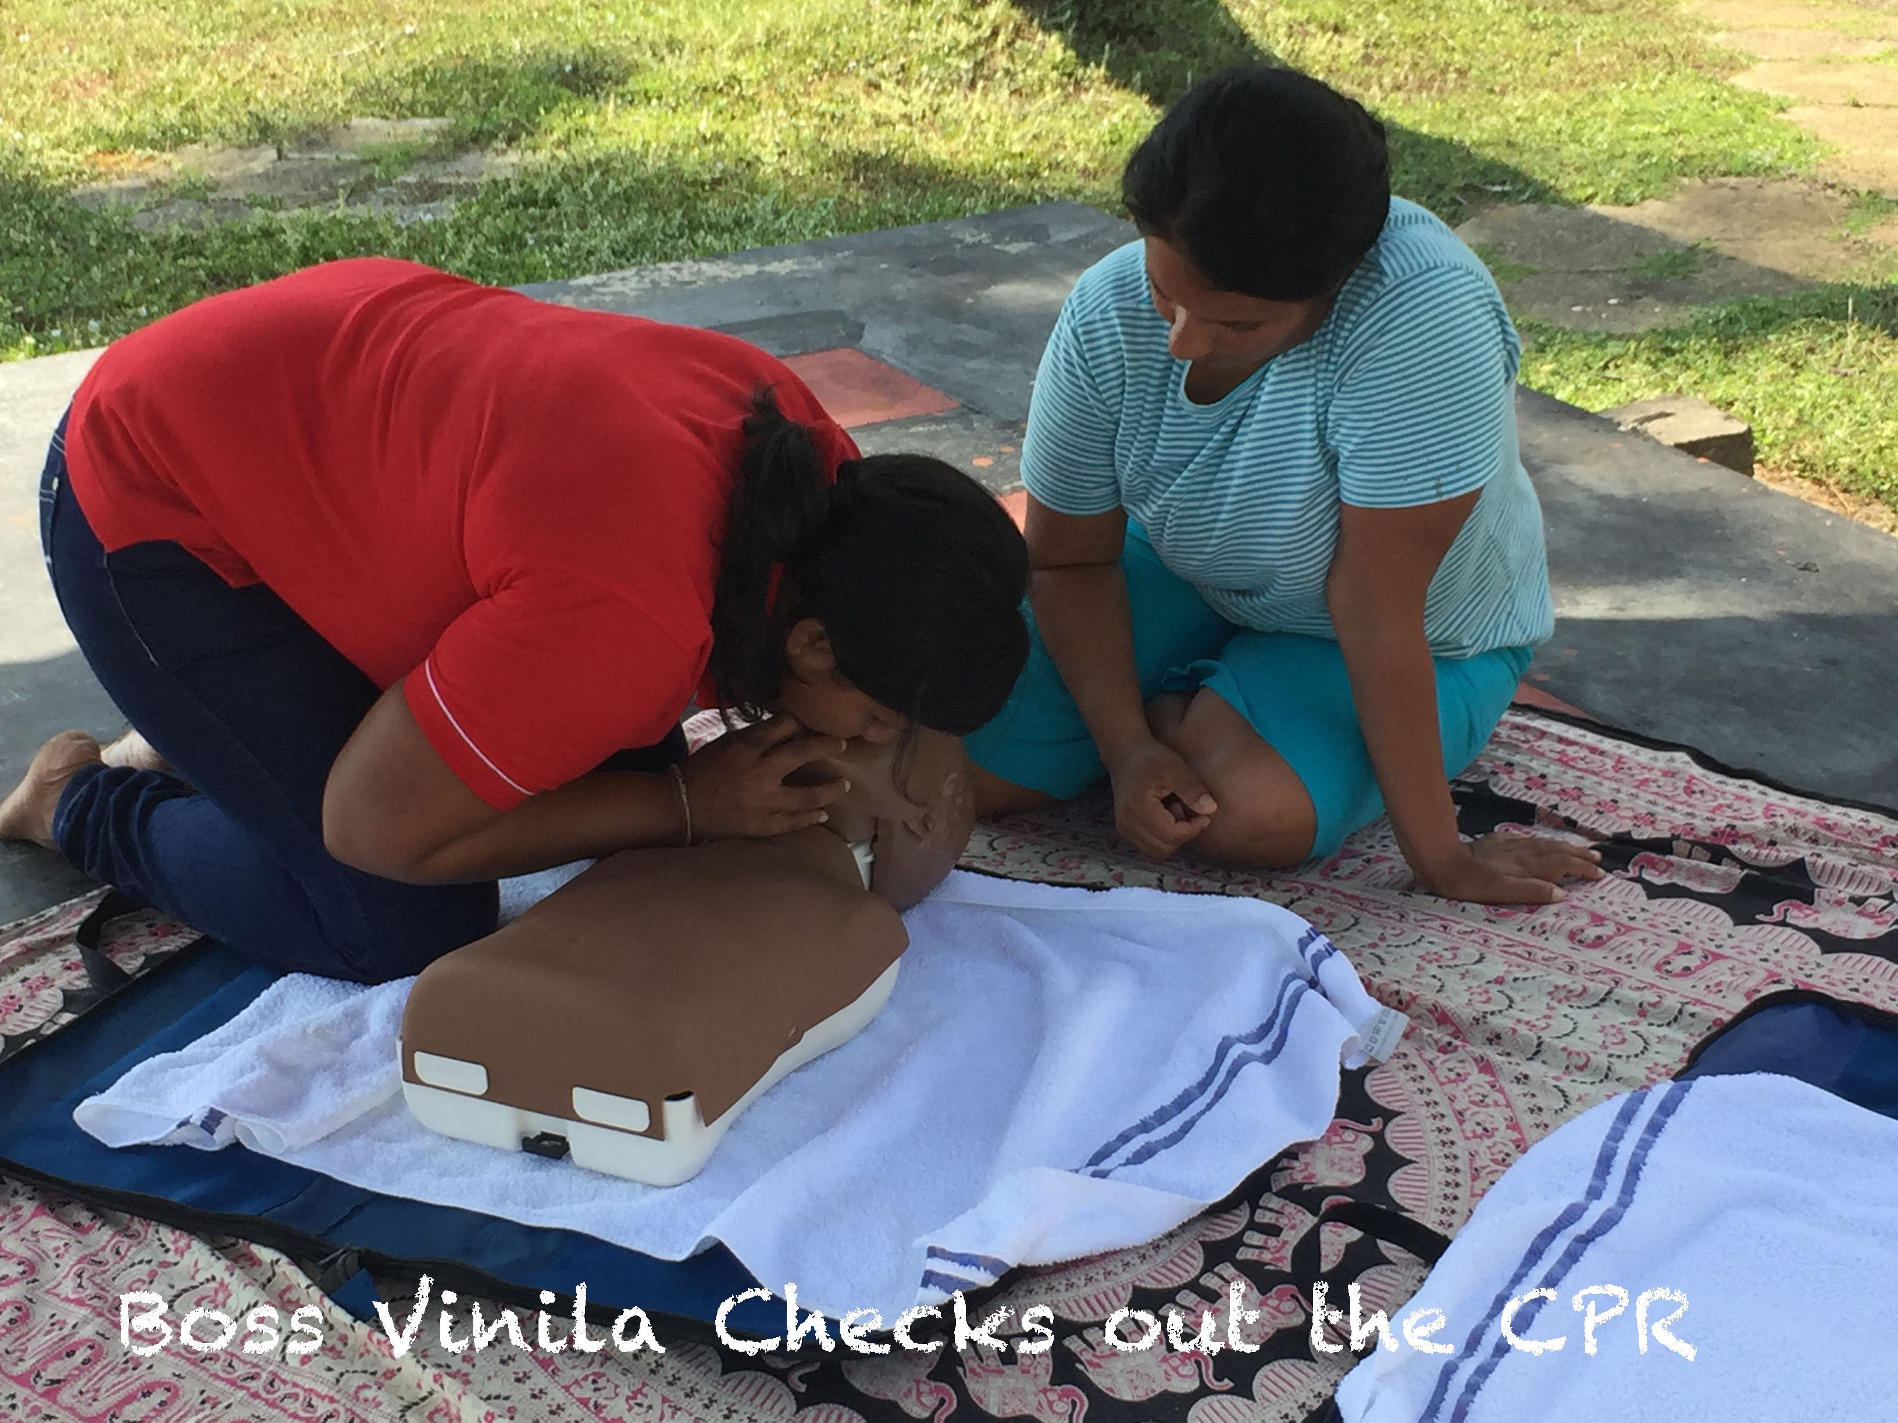

The joy of running this training is the enthusiasm, and enlightenment that success brings to non-swimmers and trainee teachers alike. Book-based classroom work and lesson preparations positively buzz with dizzying discussions across two languages. Especially fun is dealing with English figures of speech, which make instinctive cultural sense in one language, and are totally incomprehensible in another. An example is “Hold Your Breath”. In our culture, the expectation is that you will draw in a lungful of fresh air and hold there, thus providing extra underwater endurance and buoyancy. To Sri Lankans, not having been involved in childhood water play, it means the opposite: expel all the air in your lungs and stop breathing! The effect is equally negative: a premature craving to breathe in as soon as possible, no underwater endurance and, worst of all, for many, negative buoyancy! Hence the need to check what is to be said in swimming instruction by double translation. Away from the swimming environment, choose consistent words in English, have them translated by a group of swimmers into their language and then test that ‘translation’ back into English by a totally independent translator. Hence the need for Swimlish and an agreed dictionary of exactly what is meant in the host nation’s language, the Swimlish Dictionary.

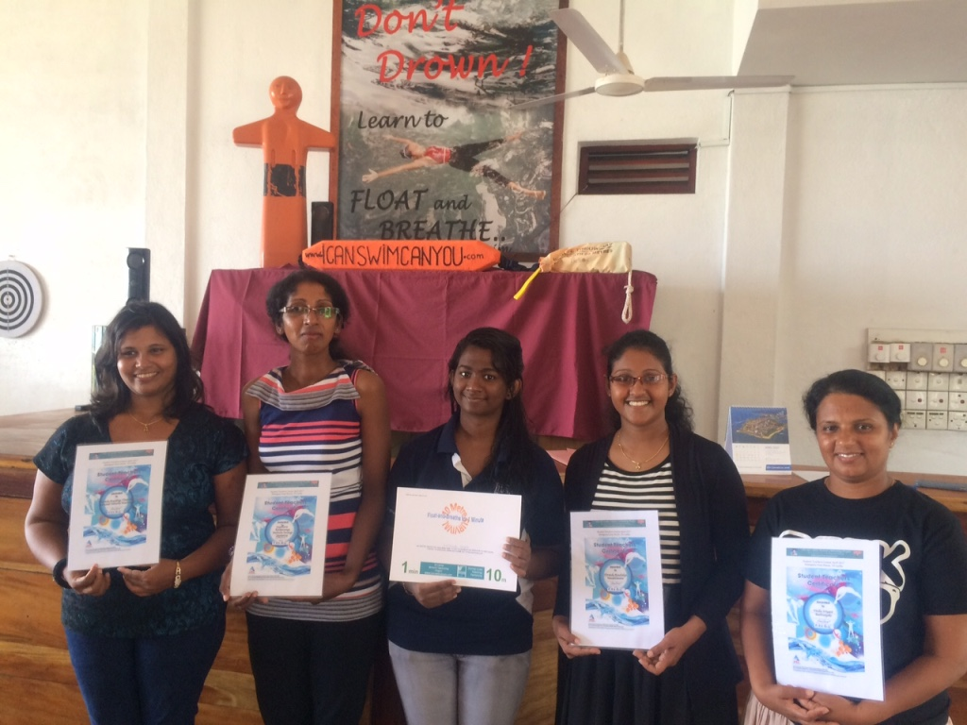
Nothing better than a meaningful Certificate to prove one has done something well.

All in all, teaching swimming in Sri Lanka, or anywhere where swimming is not yet a culturally embedded activity, is a demonstration that the battle to eliminate global drowning and save lives by teaching swimming can be a fun, meaningful meld of culture-sharing, learning and teaching experience, with swathes of personal satisfaction and achievement.

A huge Well Done to our student teachers Hirundu, Jayaweera and Uduwila, hopefully, the future teachers of hundreds, if not thousands of non-swimmers who will learn to swim by master how to Float-and-Breathe, then swim. And, of course, thanks to Vinila, our in-Country chief, and our Founder, Christina, for organizing their training and her pioneering work on the early steps of learning to get non-swimmers to swim beautifully from the first stroke.

